EXPRESS LIFE INSURANCE COMPANY LIMITED

Financial management System Analysis Report

By
Turnkey Africa Limited
Table of Contents
1 System analysis 3
1.1 Introduction 3
1.2 Purpose 3
1.3 Objectives 4
1.4 Scope Definition 4
1.4.1 Areas Covered 4
1.5 Data Collection Method Details 4
1.5.1 Interviews 4
2 Existing System 5
2.1 General Ledger 5
2.1 Financial years and journals preparation and posting 5
2.2 Cash Book 10
2.2.1 Receipts 10
2.2.1.1. Receipt Reports 11
2.2.2. Payments 13
2.2.2.3. Reports 14
2.2.4 Bank Reconciliation 17
3 FIXED ASSETS MANAGEMENT 19
3.1 Depreciation 20
3.2 Revaluation/Impairment. 20
3.3 Disposal 20
3.3.1 Inputs 21
3.3.2 Processes 21
3.3.3 Outputs 21
3.3.4 User expectations 21
4 INVESTMENTS MODULE ANALYSIS 22
4.1 User expectations 22

System analysis

Introduction
This is a system analysis document for the Financial Management System prepared by Turnkey Africa Ltd for Express Life Insurance Company Limited.

Purpose
Express Life Insurance Company Limited (“Express Life”) is a life assurance and company registered in Ghana with its head office in Accra.
Express Life, founded in 2009 currently has 25 employees working in 3 physical locations in Ghana. Express Life is currently embarking on aggressive expansion and growth in the low-income segment of Ghanaian population.
Over the coming years Express Life aims to empower more than 500,000 Ghanaians with financial safety nets and springboards to a better life. Express Life seeks to differentiate itself as the most customer friendly and responsive insurer in Ghana.
Express Life acknowledges the importance of technology in the provision of excellent customer service, business performance and deployment of innovative products & services. With that in mind, Express Life is committed to enhancing its IT infrastructure by deploying an appropriate life assurance policy administration system that would be modular, customer-centric, robust and dynamic to align with its business strategies now and in the future.
The current system(s) in use by Express Life are failing to meet the business needs of the organization in the following areas:
- The system in use is extremely difficult to readily customize to meet the ever-changing business requirements.
- The system lack integrated telephony, document management, finance and accounting modules hence multiple systems are being used.
- There is no extensive reporting module or structures in the system available to Express Life’s customer service, finance, or technical departments to be used for management information.
Our primary objectives in implementing a new System are as follows:
- To define and provide a single technology platform, including infrastructure as well as database and its developments, which will define the basis for supporting the business objectives of Express Life.
- Improve our ability to provide a world class service to our customers by leveraging technology to achieve a competitive advantage.
- Improve operational efficiencies throughout Express Life and bring all company information and results in sync.
- To provide timeous and accurate information to regulator and all stakeholders in a cost effective manner.

Objectives
The main objective of this system analysis process is to understand the existing system and processes and based on the understanding prepare the requirements for the intended system.
The main objectives of the analysis are:
- To understand the Finance Department’s existing processes.
- To identify the users of the Finance system and understand the tasks they undertake.
- To know the members’ characteristics and expectations as well as the organization and the environment on which our solutions will be operating in.
- To identify the unsatisfactory areas (with the help of users) of the current system.
- To establish a basis for common understanding.
- To computerize Finance Department’s functions.
- To build an integrated system that would provide accurate information to users (i.e. Life Insurance and Finance).
- To provide an effective, accurate and secure system.
- To provide a scalable system built using state-of-the-art technology.
- To establish a clear statement of functional and non-functional user requirements.

Scope Definition

Areas Covered
Below is the summary of what was covered System Analysis:
- Geneneral ledger
- Cash book
- fixed assets
- Investments

Abbreviations
Express Life Express Life Insurance Company Limited.

Data Collection Method Details

Interviews
Following is a schedule of the various Interviews that have been conducted at Express Life head office premises:

Personnel | Company | Department
Benjamin Annan | Express Life insurance Ltd | Finance
Cedric | Express Life insurance Ltd | Finance
Kwadwo | Express Life insurance Ltd | Finance
Adoma | Express Life insurance Ltd | Finance

Existing System
The Finance department is headed by a Chief Finance Officer and the department uses tally solutions system (for automated transactions) and manual process.

General Ledger

Financial years and journals preparation and posting
- Express Life operates a 12 month financial year starting January and ending December each year.
- They handle multi currency accounting in that they transact in various foreign currencies but at the end of the day the ledgers are maintained using the base currency which is the Ghanaian Cedi. All financial reports including the final reports(Trial balance, statement of financial position, statement of comprehensive income etc) are all presented using the base currency.
- Currently Express Life does not use cost centers to apportion costs but this will be defined in due course to be able to help track the expenses per cost center. The cost centers will be based on departmental structure of the company.
- In the current application(Tally) the accounting periods are closed on monthly basis. However a provision is given whereby any adjustments to be done can be done before its closed.
- Journal Entries are created in finance. When creating a General Journal the process below is followed (process is manually initiated by a finance user>>>>>the voucher is to be checked by a senior accountant>>>the voucher is posted by the user (who initiated the voucher) and the following are the inputs that need to be presented before the journal is posted (voucher number, narration, account name, account code, date and amount(debit/credit).All these information currently prepared in excel. The voucher report is used for checking before posting the journals. A journal cannot be posted if it’s not balanced and incase of any mistakes the voucher is reversed.
- There is need to have the journals be imported into the application, checked and posted once as its anticipated that the volume of journals will increase over time.
- A GL Account statement is generated which shows the opening balance of an account, the Credits and the debits and the closing balance.
- Chart of Accounts-Express life maintains a normal 3 tier structure of general ledger accounts as shown below:

5 Current assets-(Main account)
58-Bank accounts(Sub account)
58600- ADB - GULF HOUSE (Transactional accounts)
58350-BANK OF AFRICA
- The chart of accounts will have some gaps maintained to be able to take care of additional accounts. This for example will be the case for bank account GL accounts whereby a gap of 5 will be given to accommodate any new accounts opened for each bank. Any accounts coming after the gap has been exhausted will have to fit into the last number as already captured in the chart.
- It's also required that the users can expand or shrink the chart of accounts at any given time as the need may arise.

    - Budgeting
- Budgeting generally refers to a list of all planned expenses and revenues, the objectives being to provide a forecast of revenues and expenditures. Currently the budgeting process is a mix between 0-based budgeting and incremental decrease/increase from the previous year actual figures. The budgeting process is for both income and expenses. The budget preparation always starts in the 3rd Quarter of the preceding year. I.e. the income and expenditure budget for 2014 preparation started in September and should be done on or before December 2013.The following are the guidelines for preparing the budget:
- The budget is prepared based on various assumptions which include new financial year projections(e. g increase in salaries due to the company's expansion programme,inflation, exchange rate trend as observed in the current year etc). Every department is responsible to send its projections to the finance department after which the finance department then goes ahead to consolidate all the assumptions that have been presented by the departments to come up with a complete, comprehensive organizational budget.
- The departments will submit the budgets as distributed in all the periods within that financial year
- A common factor(specifically for particular items) will be applied of the preceding year's actual figures while some items will have their budgeted figures increased or reduced depending on the assumptions as stated during the budgeting process.
- All budgets are prepared on base currency.
- The budget is prepared by the finance department, reviewed by management and later approved by the board.
- Budgets are currently being used to monitor and control expenditure. This is mostly used when purchases are being done. Before any purchase is made the budget allocated to that cost center/department will have to be checked first.
- Currently once the budget has been approved by the board but it can be revised if the board advise so.

Challenges facing the budgeting process
- The budgeting process is done in excel. This in turns makes it time consuming for the personnel in the finance department to be able to link the budgeted figures from various departments/cost centers/income heads to the consolidated budget.

User expectations
- As the company grows so is the budget. This means its preparation becomes more complex it's expected that the users will be able get a solution whereby little human intervention is required so as to reduce on the mistakes done during budget preparation
- A solution which will be able to save on the time(ability to import the budget estimates per cost center) of which the budget is matched against the accounts and also linked to the final reports that require the budget figures to calculate variance hence giving real time report outputs.

    - Final reports

- Express Life reports to both management and the National Insurance Commission(NIC) which is the Ghana insurance regulatory body.
- The NIC reports are submitted every quarter while the management reports are submitted on monthly and quarterly basis.
- The NIC reports are prepared and submitted as per the formats provided by NIC. Below is a listing of reports:

      - National Insurance Commission

- SDR 1-Capital resources
- SDR 1i-regulated technical provisions and their coverage
- SDR 2-Statement of Assets
- SDR2i-Liabilities and Equity
- SDR 2ii-STatement of foreign assets and Liabilities
- SDR 2 iii-Other assets and Liabilities and Off balance sheet Liabilities and assets
- SDR 3-Statement of Income
- SDR 3i-management Expenses
- SDR 3ii-Other management Expenses/Other Income/Other Investment Income
- SDR 5-Reinsurance arrangements(to be generated from the life system).
- SDR 7-Statement of Investment Summary
- SDR 7i-Investment in subsidiaries Affiliates and related parties
- SDR 7ii-Statement of other Investments
- SDR 8-Statement of changes in policies and Premiums(to be provided from life system)
- SDR 8i-Statement of Actuarial Liabilities(to be provided from the life system)
- SDR 9-Statement of outstanding payments of policyholder benefits(to be provided from the life system)
- SDR 10ii-Shares portfolio
- SDR 10iii-Statement of policies to shareholders, Directors and Officers(to be provided from life system)

      - Management reports:

- Balance sheet(statement of financial position)
- Trial balance
- Revenue Account
- Income surplus Account(statement of other comprehensive income)
- Income statement account
- Management Expenses
- Statement of cash flow
- statement of changes in equity(template to be sent by Cedric)
- schedules to the accounts(creditors, debtors)(format to be sent by Cedric)

N/B
- All the above formats have been provided except for report 8 and 9 under management reports).In case any further explanations if needed I will be able to come around for consultation. The formats will be in the reports analysis document which will be sent together with the finance system analysis document.
- The notes of Accounts will be done out of the system.
- The reports marked in yellow will be generated from the life(LMS) system

- Some reports are submitted to the NIC are not part of what will be generated from the application due to the nature of data in the report and they include the (the ones in green above) in addition to the below reports
- SDR2iii
- SDR 7i
- SDR 7ii
- SDR 10
- SDR 10i
- SDR 10iv
- SDR 10v
- SDR 10vi
- SDR 10vii

Challenges for final reports preparation
- Apart from the trial balance which is updated when journals are done to the tally application the rest of the reports(statement of financial position, Income statement etc) need to be prepared manually hence a lot of time is lost.
- No real time reports can be attained as it needs human intervention to be prepared.

User expectations
- Be provided with a solution which can be able to update the final reports real time so as to save on time used for their preparation.
- Get a solution which will reduce human intervention for the final report output to be finally generated.

Cash Book

Receipts
- Currently Express Life issue 2 sets of receipts manual and printed ones. The manual receipts are issued for all new business transactions because the information about the client is not yet in the current life system application. Any other subsequent receipts for an already existing business is printed as the information and details about the client are now in the application. The cashiers from all branches are responsible in receiving the monies and issuing a manual or a printed receipt to the client.
- The manual receipt is issued in triplet. One copy is for the client(Original copy),another copy is for the operations department and last copy is for the Finance department.2 receipt copies are issued for the case of a printed receipts whereby one copy is for the client and the other copy is for finance department.
- Express Life accepts money received in different forms including cash,cheque,EFT,standing orders(no receipts issued for this mode) and bank deposit slips.
- Post dated cheques are also accepted but the receipt is only issued when the cheque has been confirmed as matured and money reflected in the company's account
- Money can be received in base currency and other foreign currencies(USD being the most common one for now).Monies received in foreign currencies is deposited in the account meant to receive foreign currency money.
- Express Life maintains cash and cheque collection boxes in the office where by at the end of the day or following morning the collections are taken to the bank for depositing. Bank deposits are supposed to be done once a day but because some money might come in when the bank is already closed the unbanked money will be taken to the bank the following morning. A bank deposit slip is issued by the bank as proof of the transaction. The cashiers are responsible in doing the bank deposits.
- Apart from normal business(Life business) Express Life insurance also receives monies from investment trading and dividends but these are not receipted - as the transactions are direct transfers to the company's account. However in the long run other forms of receipting will have to be added like disposal of assets.
- The company has both brokers and Agents and all these are paid on commission basis. They are NOT allowed to deduct commission from the clients amount in case they receive the money on behalf of the client(which is highly discouraged).All clients a tied to an agent/broker.
- The receipt number includes serialized numbers which are preceded by the short name the product code as defined in LMS e. g(EXP101,EXP202 etc).For this case as an example EXP1 is the product code(Farewell plan) then 01 is the serialized receipt number.
- Commission to brokers/agents is twice in a month. The payments are done in cheque or EFT.All brokers are paid using cheque but agents are paid using EFT.However if an agent has no bank details then payment will be done in cheque.
- The receipt issued captures the following details: Receipt date, Received from (Client name), sum of in words, being payment of(narration), policy number, cheque number, drawer’s bank, cheque date, amount in figures, cashier name, client email address and tel number and the signatory.

Receipt Reports
- Receipt report
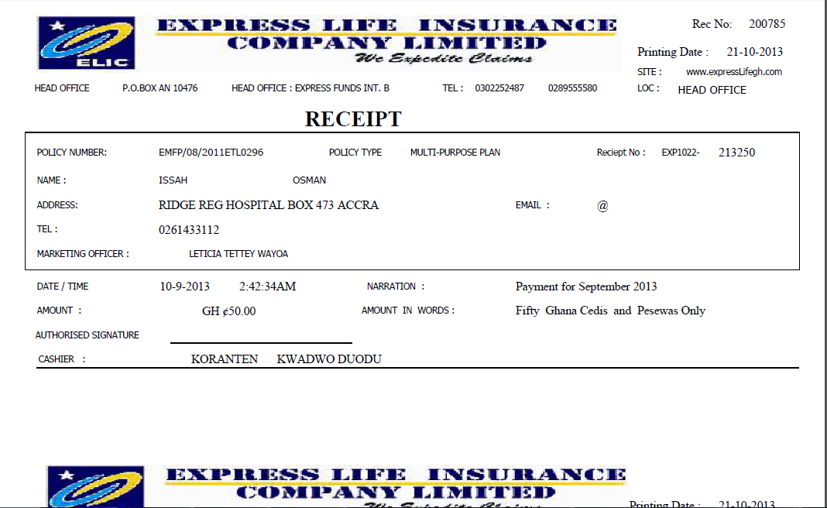

Fig 1.1

- Cashier's daily report
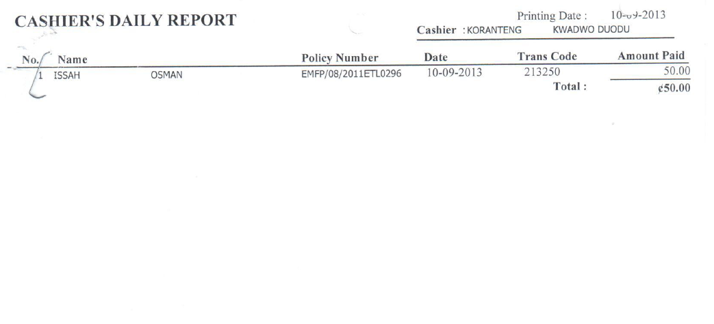
Fig 1.2

Challanges facing receipting process
- Unable to print receipts for new business transactions
- Unable to automatically update the cash book real time as it requires that receipt journals be done to be able to get the cash book balances updated
- Unable to allocate the receipt amount during receipting thus delays on updating the relevant ledger accounts

User Expectations
- Ability to be able to save a receipt and print it later and it has to bear the original details of when it was captured including the receipt date
- Ability to allocate receipt amounts received to the policies/loans at the point of receipting. This will enable real time updating of the financial books and in turn prompt reports which can be used for decision making.
- Ability to print receipts for both new business and existing policies
- Ability to reverse receipts which will in turn reverse the whole transaction in the cash book and the individual client(in LMS).
- Ability to be able to assign cash and/or cheques to the person doing the bank deposits and be able to print deposit slips direct from the application.
- Integrate the receipting function with the bank reconciliation process so that there is an automated reconciliation process.

Payments
- Express Life currently operates 20 banks. All these bank accounts are in Ghana though 2 of the accounts currently are the ones for foreign currencies. The rest are for the base(Cedi) currency.
- The modes of payment used by the company are Cheque,EFT,RTGS. Cheque payments are the most commonly used mode of payment.

      - Cheque processing
- A memo for payment is issued(request for payment).
- The memo is then approved by the Head of Department
- The HoD sends the approved memo to the CFO for vetting
- CFO then sends the memo to the CEO for final approval(Please note that this level of approval is only necessary when the amount requested is deemed to be above 1000 cedi but it might vary depending on the kind of transaction as well.
- Any amounts more than 100,000 Cedi need to get approval of the CEO and 1 shareholder.
- Once the CEO has approved the memo the request is then taken to Finance for cheque processing. Finance will prepare a payment voucher and cheque
- The head of accounts cross checks the cheque for accuracy purposes and its then sent to the signatories before it’s finally issued to the client.
- Cheques can be issued for any amount. There is no limit as to what amount can be issued. However if the amount is more than 100,000 Cedi then one of the shareholders will have to be part of the signatories.

      - EFT processing
- EFT mode is rarely used but when used then the attached EFT schedule is sent to the bank.
- This mode is used commonly for paying agents their commission.
- The EFT schedule has the Name of payee, bank account of the payee, bank code, amount per payee, narration and the grand total in to be transferred. This is accompanied by an instruction letter from Express Life Insurance to the bank stating the amount to be paid and duly signed.
- Express Life computes Withholding Tax (WHT) as per the withholding taxes rates in Ghana as shown below.

Summary of Withholding Taxes in Ghana Payment | Resident (%) | Non-resident (%)
Goods | 5 | 10
Services | 5 | 15
Rent | 8 | 15
Dividends/Commission | 10 | 15
Board fees | 10 | 15
Fig 1.3
- The WHT can be deducted from amounts to be paid e.g. If paying commission Express Life, pay the commission less the WHT.
- Express Life does not issue WHT certificates.
- Express Life is does not collect VAT from its clients as it's not a registered tax agent.

Reports
    - Cheque report
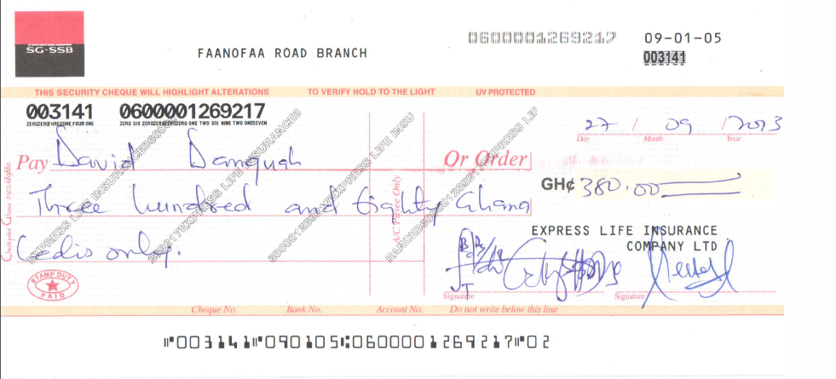
Fig 1.4

    - Petty cash Analysis
- Express Life at the moment operate only 1 petty cash box and this is maintained in the head office. However the petty cash and account imprest (cash advance) will soon be extended to the other branches.
- The petty cash box is maintained in base currency.
- The petty cash float for has an upper limit of 1,000 Cedi and no minimum. The amounts available in the box can be issued to 0 balance at which time the box will be replenished. However the box can always be replenished any other time after substantial amounts have been issued already.
- Express Life also operates (Account imprest).This is same as cash advance where-by a user is issued with money according to his budget and after spending if there is any deficit he/she will be refunded the excess used but if there is any balance then the staff will have to take back to the cashier for receipting and he/she will be issued with a receipt.
- The maximum amount that can be issued from the petty cash box is 50 Cedi but at times the amount can be more depending on what expense is to be incurred using the petty cash amount.
- Once the user has been issued with the petty cash he/she has to bring back necessary documents to show how the amount was spent. These documents are used for monitoring the use of the petty cash amount whereby the amounts issued are matched against the documents returned as proof of spending the money.
- Petty cash refund is also allowed. If a staff goes out and uses his/here own money, the staff will be refunded the amounts spent but this has to be matched against the documents produced(receipts, bus tickets, invoices etc) as proof of expenditure then a voucher is raised and authorized by the HoD or head of accounts and the refund will be made.
- The petty cash process starts by the staff who wants the money, makes a request. Finance then issues a voucher. The voucher contains the following details (date, details of expenditure, quantity, unit price and amount).The staff then fills the petty cash voucher with details of what he/she wants. The HoD then authorizes the voucher. The Head of finance then approves and the money is then issued to the staff in need. The user has to then acknowledge the cash received.
- Commission is NOT paid from petty cash account.
- At re-imbursement of the petty cash float a re-imbursement schedule is generated first and it has the following details (Name of person issued with money, date when money was issued, Details of the expenditure, Account name for the expense GL debited, Account code for GL number of expense account debited, Amount issued, grand total being total amount to be replenished.

      - Reports
- Petty cash voucher
Re-imbursement report

Voucher No: 0048

PETTY CASH VOUCHER
DATE | DETAILS OF EXPENDITURE | QTY | UNIT PRICE | AMOUNT GH¢
 |  |  | GH¢

Requested by: Authorized by: Head of Finance Received by:

Name,Sign,Level,Date Name,Sign,Level,Date Name,Sign,Date Name,Sign,Date

Fig 1.5

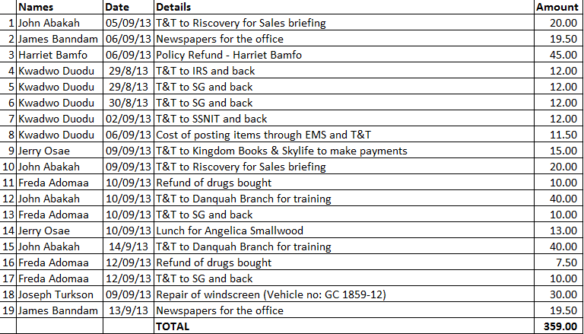

Fig 1.6: Re-imbursement report

Bank Reconciliation
- Bank reconciliation is done for all the 20 accounts currently operated by Express Life.
- The transactions which are in the bank statement and were not yet captured in the cash book are updated in the cash book before the reconciliation starts. These transactions include bank charges, direct deposits and interest, dividends etc.
- Reconciliation is currently is done manually and on a monthly basis for all the banks that the company operates an account with.
- Express Life acquires a bank statement from the bank then extracts the GL account for the bank to be reconciled after which the transactions in the cash book(GL of the bank) are matched one by one with the entries in the bank statement. The transactions that match (reconcile) will be knocked off/cleared.
- The items which will not have reconciled will form part of the reconciliation report and will be carried forward to the next period's reconciliation. These unreconcilied items comprise of unpresented cheques and uncredited receipts.
- The reconciliation report is then generated at the end of the process.

      - Reconciliation reports
- Reconciliation report

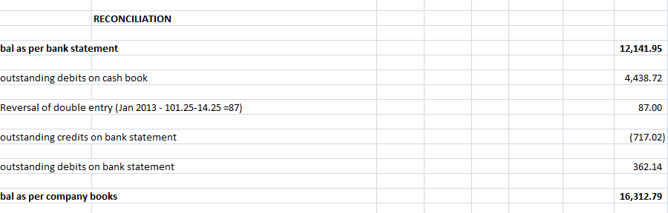
Fig 1.7

Challanges faced during reconciliation
- Manual matching of the bank statement and the cash book.This process is tidious and time consuming and bound to many mistakes as the process is done with total human intervention
- The missing transactions in the cash book need to be captured one by one before the reconciliation is done.This also wastes a lot of time and its accuracy is not guaranteed.

User expectations
- Provide a solution with the ability for bank statements to loaded electronically or entered manually
- A solution where by automatic or manual matching between bank and in-house transactions(cash book) is managed. Automatic re-matching of bank statement should also be provided.
- An application that does multi-currency bank reconciliations.
- Automatic creation of transactions not already in Accounting System (i.e. bank fees and interest)
- Ability to view previous bank statements online(these are the statements already imported into the application.
- Ability for the application to provide reports on non-matching items and missing
items after the reconciliation has been done.

FIXED ASSETS MANAGEMENT

- Express Life have divided the assets into 2 major groups namely Tangible assets and Intangible assets.
- Under tangible assets we have the following categories/classes(Office equipment, Computer equipment, Furniture and Fittings, Motor Vehicles, land)
- Under Intangible assets we have software.
- Once an Asset is procured, its details will be updated in the Fixed assets register. The information include(Purchase date, description/asset name,location,cost,user,opening and closing accumulated depreciation, monthly depreciation and net book value(NBV) )
- Currently Express Life uses the format (branch/cost center/item name(short description)and serial number) to number their assets but this has only be implemented in the IT department for now.
- For an asset to be procured the management makes a decision for the asset to be purchased, such assets must have been budgeted for..
- Currently the management of fixed assets is done manually and once depreciation, revaluation/impairment or disposal is done the values are posted to the books using journals.
- Every class/category of fixed assets have the depreciation rates and they are as shown below
- Office equipment--------------25%P.a
- Computer equipment----------33.3%P.a
- Furniture and Fittings---------33.3%P.a
- Motor vehicle------------------25%P.a
- Land----------------------------0%P.a
- software----------------------20%P.a

- The fixed assets have the useful set per category as shown below
- Office equipment--------------4 Yrs
- Computer equipment----------3Yrs
- Furniture and Fittings---------3Yrs
- Motor vehicle------------------4Yrs
- Software-----------------------5 Yrs

Depreciation
- Depreciation is done using straight line method for all assets.
- Full depreciation is done on an asset in any category in the month of purchase regardless of the date of purchase.
- No depreciation is done on an asset in the month of disposal.
- Depreciation is done on Monthly basis using the below formula

Monthly depreciation= Cost of the asset-Residual value
Useful life of the Asset
- The residual value for all assets is 0.

Revaluation/Impairment.
- Currently Express Life does not do any revaluation on assets but if done below are the accounting entries;

Dr Asset cost account(By revaluation surplus)
Cr Revaluation surplus account(by revaluation surplus amount-balance sheet item)

In case of Impairment;
Dr Impairment account(by Impairment value-income and exp item)
Cr Asset cost account(by Impairment)
- General ledger accounts are maintained per the class of the asset and this will include the cost account and accumulated depreciation account.

Disposal
- If the company feels the fixed assets has outlived its useful life or it’s fully depreciated then it can be disposed off. The accounting treatment is as below:
1. Dr Disposal Account (by asset cost value)
Cr Asset Account (by asset cost value)
2. Dr Accumulated Depreciation Acc (by asset cumulative depreciation value)
Cr Disposal Account (by asset cumulative depreciation value)

3. Dr Bank Account (amount received on disposal) Cr Disposal Account (amount received on disposal)
4. Dr Disposal Account (by the value of gain)
Cr Sundry Income Account (by the value of gain)
5. Dr Expense Account (by the value of loss)
Cr Disposal Account (by the value of loss)

Inputs
- Capturing Asset Details
  - Date
  - Description
  - Quantity
  - Department
  - Location(physical location and person in charge)
  - Cost

Processes
- Depreciation
- Disposal
- impairment/revaluation

Outputs
- Fixed Assets Register

User expectations
- Ability to do depreciation, revaluation/impairment and disposal faster and have the process automatically update the GL accounts without passing journals manually.

INVESTMENTS MODULE ANALYSIS
As from the discussion I had with the user(Cedric) the company is yet to trade in Government bonds/Bills and Loans. However the company trades in shares and deposits but there was no clear way of how these 2 kinds of investments are managed. It was therefore agreed that I do the Turn-Quest application demonstration of how all the above items are managed in the application and the user will either agree to adopt the processes as is or make recommendations which will thereafter form part of the investments module analysis.

User expectations
- Ability to capture investment details with applicable exchange rates. This applies to investments which are done using foreign currencies.
- Ability to categorize investments into equity, bonds, fixed deposits or treasury bills
- Ability to differentiate cost of investment and administrative costs
- Ability to automatically post transactions done from investments to the ledger accounts.

Signed for and on behalf of:
Express Life insurance Ltd

As the duly Authorized Representative:

Signature: Name:

Date:

As the duly Authorized Representative:

Signature: Name:

Date:

As the duly Authorized Representative:

Signature: Name:

Date:

As the duly Authorized Representative:

Signature: Name:

Date:

In the presence of as Witness:

Signature:

Name:

Address:

Signed for and on behalf of:
Turnkey Africa Ltd

As the duly Authorized Representative:

Signature: Name:

Date:

As the duly Authorized Representative:

Signature: Name:

Date:

In the presence of as Witness:

Signature:

Name:

Address:

